**COMP4:**

**FIGHT SIMULATOR**

Daniel Ray

Ecclesbourne School

Contents

Glossary 3

Background to the Problem 3

Interview with the Primary Client 3

End User 7

Acceptable Limitations 7

Existing Systems in the Area 8

Objectives 8

Stretch Objectives 9

Modelling 9

## Glossary

-40d20: Rolling a d20, or 20-sided die, 40 times.

-PCs: player characters.

-homebrew: things that are fan-made for D&D, rather than official creations by Wizards of the Coast or TSR (original creators of D&D)

-Monster Manual: a book for D&D that provides statistics and background for various enemy types.

## Background to the Problem

Joe is a Game Master at Distinct Gaming, a game shop in Belper. He often runs large-scale combat encounters involving his players’ characters and lots of other creatures, but he is often unsatisfied with the result as he has to make approximations in order to manually work out what is most likely to happen. Joe has requested the creation of a ground-up program in VB which simulates battles between creatures, any of which the user can choose to control. The purpose of the game is for the creatures to be customisable, so that each effect applied and each attribute can be changed. This will allow Joe and game masters like him to accurately simulate large-scale battles in a fully customisable environment.

**Interview with the Primary Client**

Q: What’s your existing system for simulating large-scale battles?

JM: There are a few tools online for that with various problems, like using real-time mechanics or just not being customisable enough. Another approach is manually running it with statistical simplifications. For example, instead of rolling **40d20** with a 3/20 chance of success, you just say there have been 6 successes. This still involves calculating probabilities though, and it only works for large groups with the same statistics. Often in my battles there are lots of unique types of creatures with their own statistics, so that often isn’t very effective. Also, I have to decide which creatures are hit (if it’s an attack roll), which is not ideal. There is another alternative though, which is to make up the whole fight and guess at the result, but that’s not appropriate when player characters are involved. It also doesn’t give accurate or interesting results most of the time, and a lot of the fun aspects of these fights

Q: What type of battle would you like this program to be focussed towards?

JM: It would be most helpful when the battlefield is big, with lots of combatants, but it would still be more practical than normal D&D if there was lots of detail involved in each creature, like if every monster had its own unique magic sword. In those cases, there are lots of adjustments and effects that I wouldn’t be able to remember. It would also be useful to be able to fully automate a battle so that I can run the battles multiple times quickly, particularly if there are no **PC**s involved. It would also be best if it was aimed towards the more common tiers of character levels, i.e.: levels 1-10.

Q: What are the key aspects of 5th Edition D&D that you want to be faithfully recreated?

JM: The combat rules regarding adjustments from magical weapons, shields and armour, magical item effects like the extra damage from the Flame Tongue, and elemental resistances and immunities, and the “to-hit” adjustments and speed from the creature itself. Also, the option of any creature being automated is a must-have. It would also be nice to have support for special abilities of creatures, like the Medusa’s petrifying abilities.

Q: What is not important that’s in the D&D system?

JM: Picking up or passing around items during combat, house rules, extra damage from critical hits and miscellaneous effects of spells, like the paralysis from Hold Person, are not essential, although they would be nice to have in cases where spell-casting monsters are involved. It also needs to be able to tell what side of the fight each creature is on. I also want to be able to add and select scenarios from a list, and to be able to define and add new creatures and items.

Q: Could you give some examples of creatures and items you might want to add?

JM: Weapons with basic attributes like “+2 to hit” are a must, I’d like to be able to add additional damage type, for example the Flame Tongue's extra 2d6 Fire damage. The damage doesn’t have to be randomized, though. It would also be really nice to have some more complicated weapons like the **Sun Blade**, with its extra damage against Undead, but that’s not necessary if it gets in the way of other functions. It would be sufficient to account for other types of items, like Amulets of Health, within the creature’s statistics, as it won’t be changing mid-battle. Actually, items changing hands isn’t really necessary at all, because in practice it’s unlikely that any creature is going to pick up an item during a fight instead of attacking. With regards to creatures, I’d like to be able to enter data straight from the **Monster Manual**, like for the **Hook Horror**. It would be nice to be able to add spell-casters, especially low-level, damage-dealing spells like Magic Missile and Firebolt. It’s not necessary to cover spells at all, but the more are covered the better.

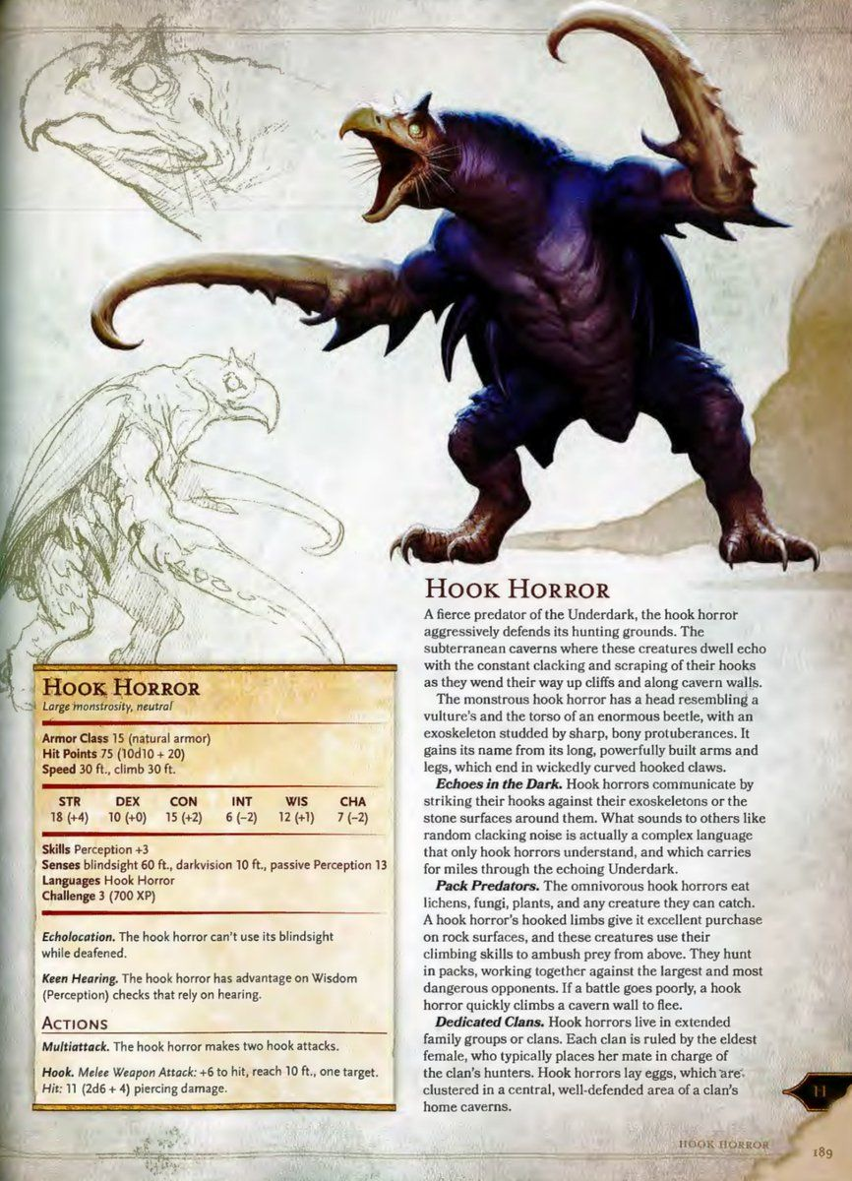

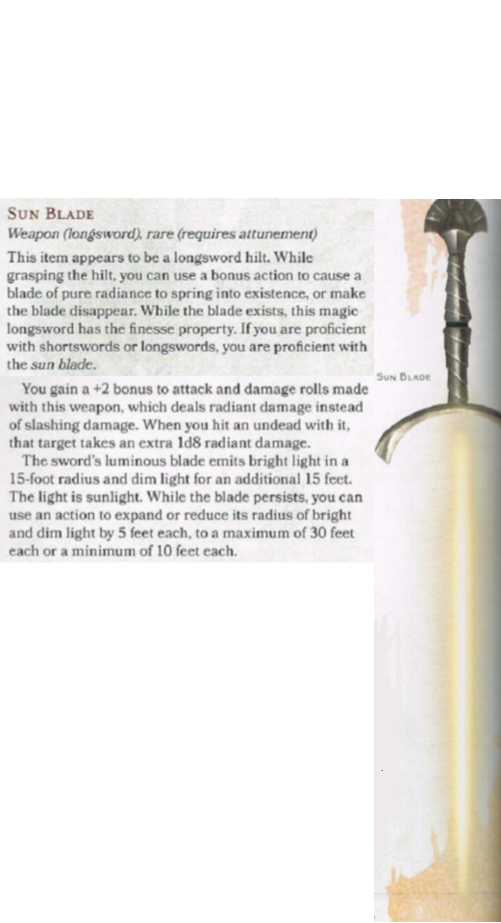

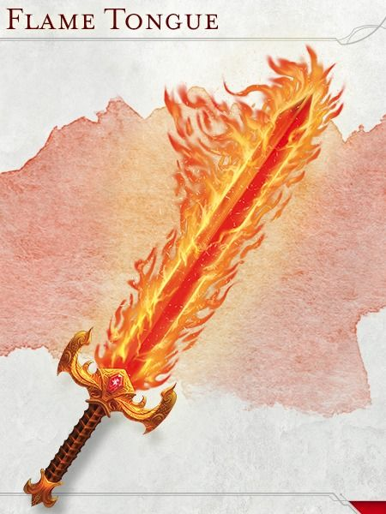

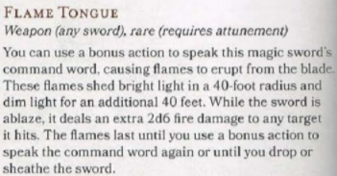

Q: How do you want these to be added?

JM: However is needed to allow maximum freedom of customisation. It’s crucial that I can make **homebrew** creatures and other things that wouldn’t normally be in an encounter fit into the simulations.

Q: It would be virtually impossible to create a user interface that creates new classes. Would it be acceptable to enter new data directly into the code of the program?

JM: As long as it provides more customisability in what I can create for the simulations, that would be fine. However, for the purposes of accessibility, it would be preferable to use configuration files to add data instead.

Q: How would you like the user interface to function?

JM: It needs to be turn-based, and it needs to tell me what each manually-controlled creature can do, and present it as a set of options. Presentation isn’t as important, being a GM tool. I also want to know what happens to each creature on each turn.

### End User

Primarily, the end user is game masters and players who want to run and control large-scale battles. However, as it is being created with the goal of being customisable and open-source, the end user is more specifically people like Joe who want to be able to customise and create creatures, put them into a simulation and watch them fight each other

## Acceptable Limitations

* As the program is intended for large-scale simulations, implementing a system within the program to customise every aspect of each creature would be impractical to use. Therefore, it would be acceptable to relegate the addition of each individual simulation to the hard-coded statistics, numbers and positions of each creature. As the game is intended to be open-source, this still allows users to change what they want about each simulation by editing the specific creatures used, provided they have some familiarity with Visual Basic. Therefore, the game is configured for each individual scenario it is used for, and customised for other scenarios through the game code.
* Area-of-effect (AoE) attacks will be impractical to run. This is because large-scale battles would require large numbers of creatures being checked for their position when such an effect (e.g., a Fireball spell) takes place, which would be likely to cause problems for game performance. This is exacerbated by the issue of displaying such an effect using VB. This means that battles involving spellcasters will be unfeasible.
* As the program is intended as a tool for the GM as opposed to a game, basic graphics are sufficient for the display.
* House rules, such as critical hits, are not practical to add as they vary too much between GMs to be a useful feature.
* Terrain and obstacles are not common enough in combat encounters to be necessary outside of limiting the size of the battlefield.
* As invisibility and other effects that hide the presence of creatures from each other are rare inside of combat and would be difficult to implement, they are not necessary to account for, i.e.: all creatures are assumed to know where all other creatures are.
* As most creatures are Medium size and other sizes would be problematic to the program, it would be acceptable to assume all creatures are of Medium size.

## Existing Systems in the Area

Several existing programs have attempted to simulate fights, and many have become popular in recent years. Many such programs also include the ability to take manual control of creatures, even mid-fight, such as TABS (Totally Accurate Battle Simulator) and UEBS (Ultimate Epic Battle Simulator).

TABS mostly focuses on being challenging the player to find ways to counter various combinations of creatures (or “units”), and as such does not include customisability as one of its main goals, nor therein does it include performance on a large scale. However, it does have a connection to the Steam Workshop, where the community can develop custom units and use them in-game. It also includes a Sandbox mode, where the player controls both sides of the battlefield and has no limit to the number of units they can use. This means that both customisability and high performance for large-scale battles remain in the interests of TABS.

UEBS is a more significant competitor for our program, as its main selling point is that it allows the user to set up extremely large-scale (or “epic” as in the title) battles. It also has a system to customise units, although it has no system to customise specific equipment or effects applied to those units, so each unit is still effectively the same but with behavioural differences and different statistics.

The key difference between our program and these two simulators is that TABS and UEBS are both real-time simulators with their own rules, whereas our program is turn-based and bases its rules off of 5th Edition Dungeons & Dragons. This means that our program is a bespoke simulator for Joe’s requirements, whereas TABS and UEBS are videogames which are analogous to the environments of classical D&D.

## Objectives

1. Calculate attack range with Pythagoras’ theorem.
2. Display creature positions, and update while the PC moves.
3. Allow effects to run customisable code through the creature affected each turn.
4. Allow the player to take their actions, movement and bonus action in any order.
5. Allow the user to select from configured scenarios and run one.
6. Allow creatures to be manually or automatically controlled, as determined in configuration.
7. Provide basic intelligence for creatures under automatic control.

Apply the rules from 5h Edition D&D:

1. Adjust attack rolls based on the attacker’s statistics.
2. Adjust attack rolls based on the statistics of the weapon used.
3. Determine whether attacks hit based on the defender’s AC.

Apply damage from a successful attack based on:

1. weapon type.
2. weapon bonus.
3. additional effects from weapon attributes, e.g.: Flame Tongue.
4. defender’s resistances/immunities to damage types.
5. attacker’s Strength and/or Dexterity modifiers.
6. Modify number of attacks per action a creature takes based on its characteristics
7. Determine when a creature has been defeated.
8. Determine when a battle ends.
9. Report updates from the results of effects and attacks.
10. Display the movement and locations of creatures.

Give users the choice of what their controlled creature does on each turn:

1. user specifies what attack they use if they have multiple options.
2. user selects which enemy is attacked.
3. user determines where the creature moves.
4. Provide the user with a way to exit the simulator.
5. Provide support for some healing spells, e.g.: Cure Wounds

#### Stretch Objectives

1. Enable new items to be configured.
2. Enable new creatures to be configured.
3. Enable different scenarios to be configured.

Provide support for simplified versions of:

1. some combat-oriented spells for PCs, e.g.: Disintegrate
2. some area-effect spells for PCs, e.g.: Fireball

## Modelling

Use Cases:

- Adding or modifying scenarios

- Simulating stored scenarios (fully automated)

- Running stored scenarios (with manual controls)

The activity diagrams below describe the existing D&D rules as they will be applied in the program:

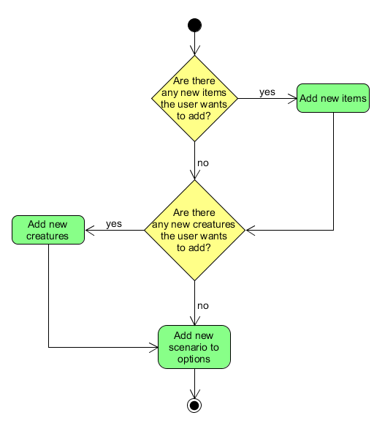

Adding or modifying scenarios:

Run scenario:

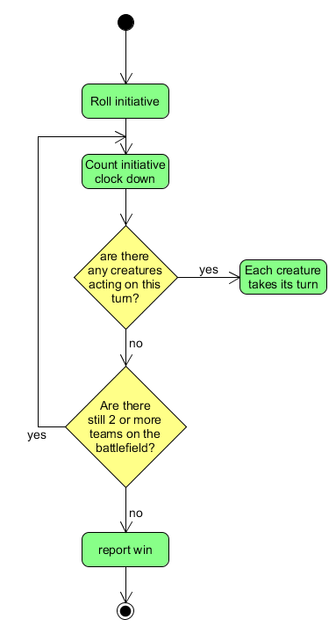

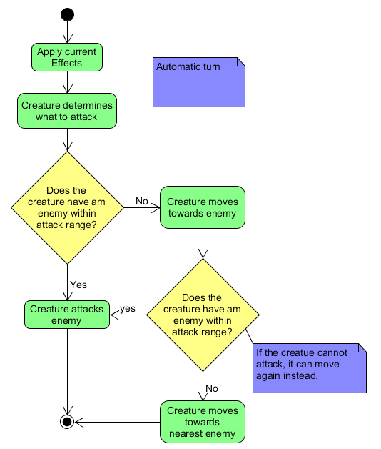

Automatic scenario:

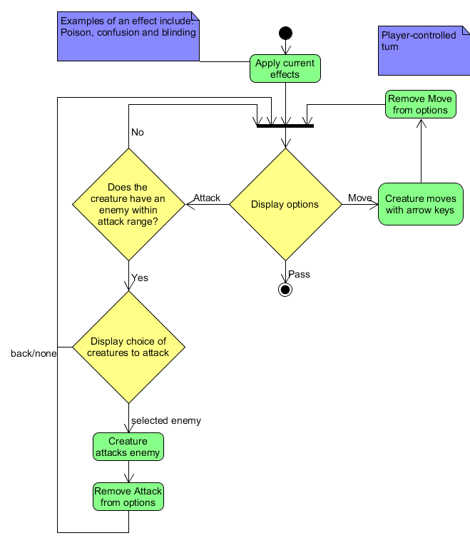

Player controlled scenario:

Creature attacks enemy:

